TAFE Invaders

Pre-Design Design Specification

Version 1.0

16/05/2020

VERSION HISTORY

|  |  |  |  |  |  |
| --- | --- | --- | --- | --- | --- |
| **Version #** | **Implemented**  **By** | **Revision**  **Date** | **Approved**  **By** | **Approval**  **Date** | **Reason** |
| 1.0 | Ben Royans | 28/05/2020 | Andrew Samway | 4/6/2020 | Initial Design Definition draft |
|  |  |  |  |  |  |
|  |  |  |  |  |  |

TABLE OF CONTENTS

1 Introduction 1

1.1 Purpose of The Pre-design Design Specification Document 1

2 UML 2

2.1 Use-Cases 2

3 Test Table 3

3.1 Test Data 3

3.2 Test Data Evidence 3

4 Unit Testing 4

4.1 Method of Choice 4

4.2 Sample Unit Test 4

5 Source Control 5

5.1 Repository Link 5

5.2 Repository Screenshot 5

5.3 Source Control UI Screenshot 6

# Introduction

## Purpose of The Pre-design Design Specification Document

The purpose of this document is to pre-face the following product design specification document in the designing phase of this software project.

# UML

## Use-Cases

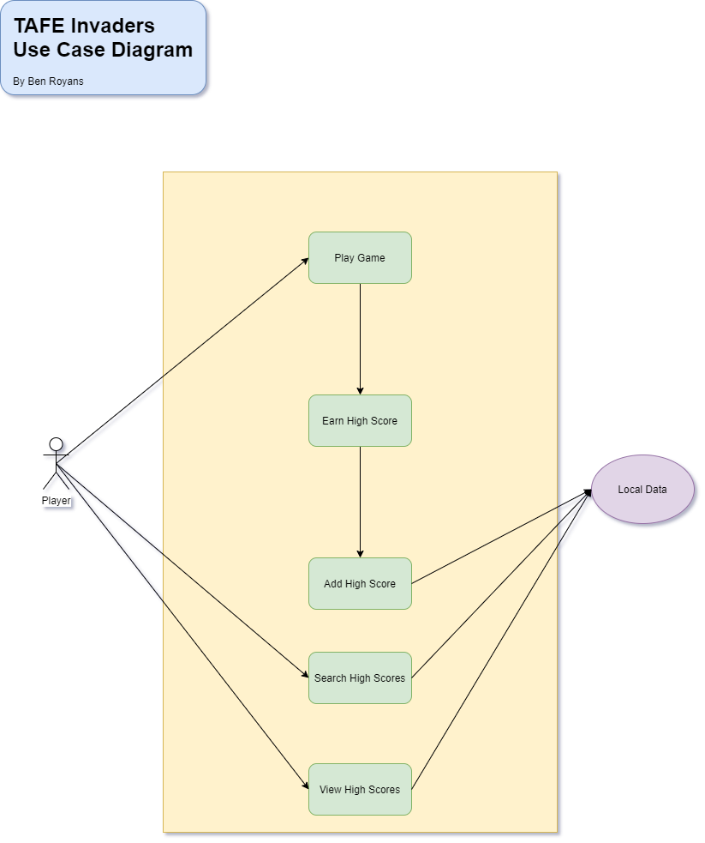

## Class Diagrams

# Test Table

Below is a sample test table which will be used for the testing of use cases.

## Test Data

Sample test data table:

|  |  |  |  |  |
| --- | --- | --- | --- | --- |
| **#** | **Functionality** | **Input** | **Expected Result** | **Pass / Fail** |
| 1 | Highscores | Enter a valid name | Highscore is added to highscores table. | PASS |
| 2 | Highscores | Enter a invalid name | Enter name dialog is re-shown to user. | PASS |
| 3 |  |  |  |  |
| 4 |  |  |  |  |

## Test Data Evidence

Sample test data evidence table:

|  |  |
| --- | --- |
| **#** | **Screenshot** |
| 1 |  |
| 2 |  |
| 3 |  |
| 4 |  |

# Unit Testing

## Method of Choice

Junit 5.4 will be used for unit testing this project as it is highly integrated with the IDE being used, IntelliJ IDEA.

## Sample Unit Test

Below is a sample unit test that tests the validity of the hashing function.

class HashTest {  
  
 @org.junit.jupiter.api.Test  
 void MD5() {  
 String testString = "This is a test string.";  
 String hashedString = Hash.*MD5*(testString);  
 assert (!testString.equals(hashedString));  
 }  
}

# Source Control

## Repository Link

The URL for the source control repository of this project is:

<https://github.com/RuggedRadius/ArcadeGameJavaFX>

## Repository Screenshot

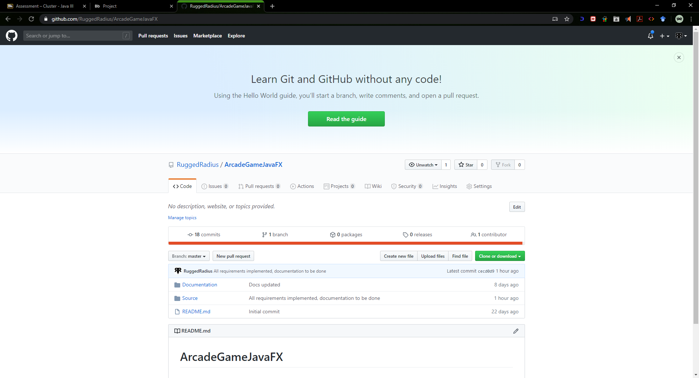

## Source Control UI Screenshot

